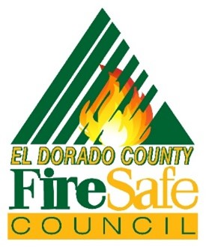
Website: edcfiresafe.org
El Dorado County Fire Safe Council

515 Main Street, Ste. 103
Placerville, CA 95667
Phone: (530) 647-1700
Email: clerk@edcfiresafe.org

El Dorado County Fire Safe Council
"Public and Private Partners Working Together to Protect People, Homes, and Natural Resources"

Board Meeting Agenda
November 19, 2025
9:30 am to 12:00 pm

American Legion
4561 Greenstone Road, Placerville

- Meeting Call to Order

- Roll Call: Sign In

- Pledge of Allegiance

- Consent Calendar Board Action Item

  - Meeting Agenda: 11/19/2025
  - Board Meeting Minutes: 10/15/2025

- New Business

  - Assistance Programs Automation – Board Action Item
  - Strategic Plan Update Approval – Board Action Item
  - 2026 Title III Program AFSC Grant Allocation – Board Action Item

- Old Business

- Executive Board Reports:

  - Chairman’s Report & Communication – Ken Pimlott
  - Vice-Chair Report –Dorothy Fine
  - Secretary Report – Angel Ball

    - Governance and New Council Formation

  - Treasurers Report: Janet Barentson

- Treasurer Report 10/31/2025 - Board Action Item

- Partners Reports:

  - BLM – TBA
  - CAL FIRE –Jeff Hoag
  - Office of Wildfire Preparedness and Resilience – Tanya Harlow
  - EDC Fire Chiefs Association – Tim Cordero
  - EDC FPO Association – Chrishana Fields
  - ENF – Brad Stewart
  - RCD – Courtney Jackson
  - SMUD – Eric Brown
  - PG&E – Mike Webb
  - EDSO –Lt Morton
  - BOR – Zarela Guerrero

- Program Reports:

  - Grants & Funding/Grants Committee– Tamara Johnston
  - Assistance Programs – Jessica Isabel
    - Chipping
    - Defensible Space Services for Seniors, etc
    - Hazard Tree Removal

  - Training Committee – Elizabeth Standeven
  - Outreach & Education – Dorothy Fine

- Community Council Reports

- Public Comment –Time limit is 3 minutes per person.

- Good of the Order

A Brown Bag Session will be held at 12:30 or 30 minutes after the meeting if it ends early. The topic will be Home Assessments Q&A, Presented by Elizabeth Standeven Training Committee. An open discussion for all to better understand the process and share experiences.

  - No business meeting in December. Enjoy the holidays!

  - Holiday Party – December 17th

  - Next EDCFSC Board Meeting – January 21, 2026

- Adjourn

